* In this section , we will talk about Green_Egypt 🍀 Design Processes and steps :

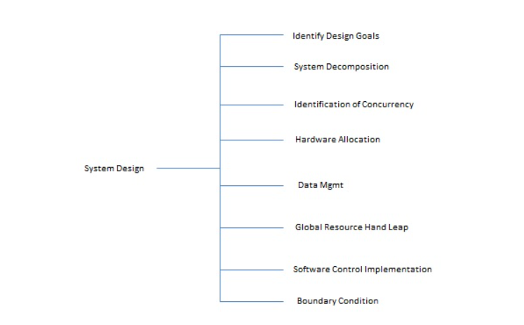

1. Identify Design Goals :

* Design a simple machine with simple UX Experience that able any one to deal with our System “system : machine and application ”.

# Goal Description :

* Green_Egypt project faces garbage problem in Egypt .
* We need to create an easy system that egyptians able to deal with and make them love the idea of the project “improve the popularity of the project idea by make the process simple as much as we can ” , so :
* we will make a hardware device which is “Smart trash ” ,

deal with plastic garbage via 4 slots “Continued” .

* project Scenario “User View” :

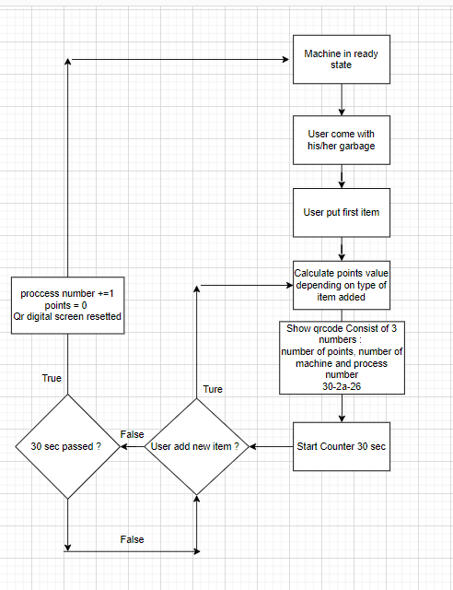

* project Scenario “Machine View” :

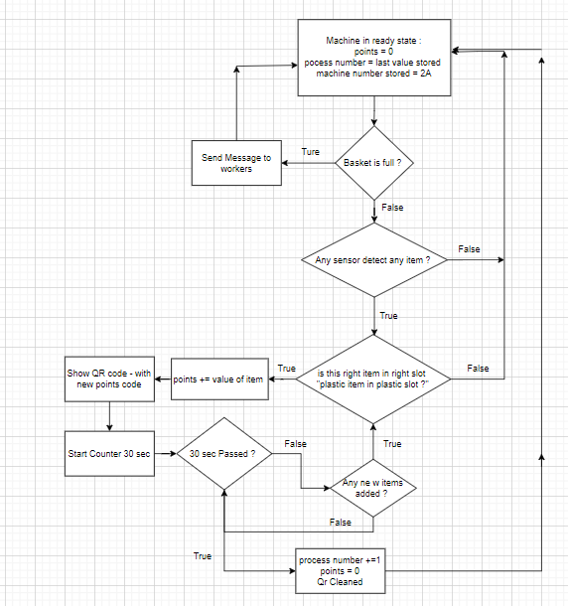

* DataFlow General Diagram “Backend - work” :
* Screens from the Application :